Welcome back! We hope you all had a lovely Easter holiday.
This half term we will finish our Transport topic and start the new topic buildings which has had to be adapted due to Covid 10 restrictions.
Personal, Social and Emotional development
The children:
- Will continue to follow our classroom rules, routines and attempt various activities with more independence.
Communication, Language and Literacy.
The children:
- Will continue to consolidate their sound knowledge by focusing on all the letter sounds in the alphabet and vowel digraphs and trigraphs.
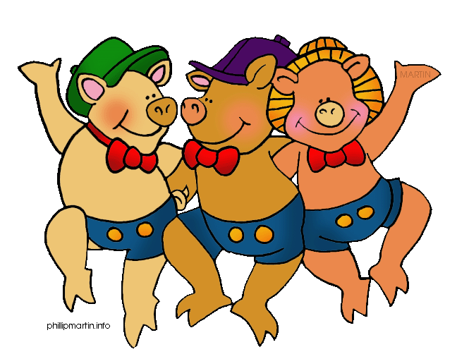
- Will continue to develop their writing skills by writing for different styles such as lists, labels and sentences.
- Will continue the Write Dance programme, which supports the development of fine and gross motor skills.
- Will continue to listen to a number of stories. They will be encouraged to think about the characters in the story, where the story is set and to make predictions about what might happen.
Mathematics
The children:
- Will continue to work with numbers 1 to 20 and beyond. They will be ordering, writing and counting with them.
- They will be continuing to find the total once an amount has been taken away. They will be encouraged to use the correct vocabulary.
- Will continue to find totals by adding two sets of objects together. They will be encouraged to use the correct vocabulary.
- Will use the vocabulary ‘heavy, light, full and empty’ to describe the weight of objects and the capacity of different containers.
- We will be using 3-d shapes to make models of buildings.

Understanding of the world
The children:
- Will be thinking about different buildings in their local environment and its purpose.
- Will be using different materials to build a house, just like the three little pigs. They will then be testing each building, to see which building is the strongest by using a hairdryer.
- Will have opportunities to use a variety of construction kits, creating different buildings.
Expressive arts and design
The children:
- Will have opportunities to use junk rubbish to develop their own ideas independently and create their own buildings.
- Will have the opportunity to learn through play in various role play areas such as a building site, shop, post office and a hospital.
- Will be able to use puppets to re enact the fairytale The three little pigs.
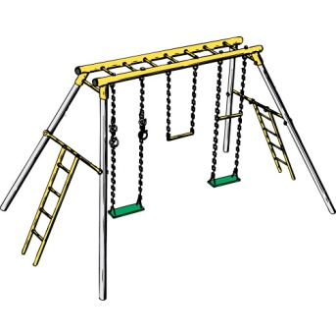
Physical development
The children:
- Will have their weekly PE sessions in the hall.
- Will continue to have a P.E session with our sports coach Martin . We will continue to develop our throwing, catching and bat skills.
- Will be developing their fine and gross motor skills through a variety of activities.
How you can help your child
- Continue to listen to your child read.
- Continue to help your child learn their key words and sounds.
- Encourage your child to attempt to spell their key words, using their phonological knowledge.
- Encourage your child to practise writing their name, concentrating on lower case letters and correct letter formation.
- Ensure that your child brings their book bag every day.
- Ensure they bring in a named water bottle each day.
- Ensure they are dressed in their P.E kits on Tuesdays and Thursdays
- Useful website www.topmarks.co.uk, (early years section) www.bbc.co.uk/cbeebies , www.phonicsplay.co.uk (phase 1,2 and 3 games)
Thank you for your support.
Mrs Wolfe and Mrs Wheeler

