Welcome back! Before telling you about what we are up to this half term, we wanted to thank you for all the support you gave last half term. I’m sure you will agree that it was a very successful start to the school year and I’m sure our lead up to Christmas will be just the same.

Our topic this half term is ‘Celebrations.’ We will be learning about celebrations that are familiar to the children such as Bonfire Night, birthdays and Christmas. We will also be learning about festivals that may not be so familiar to the children such as Diwali and Eid. During this half term we will also be looking at how our environment is changing, as we move into the autumn.

School life
We will continue to help the children feel settled in the school environment and reinforce the expectations we have of them.
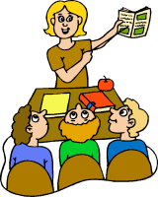
The children will continue to put away their belongings and find their name first thing in the morning.
Throughout the day the children will have opportunities to choose activities that are both indoors and out. They will be expected to complete different activities with Mrs Wolfe and Mrs Black but will also continue to choose independently.
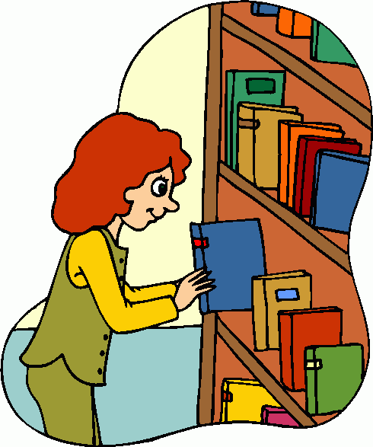
As you may have noticed the children now have the opportunity to choose a library book each week.

What the children will be learning
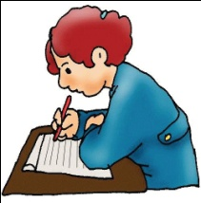
Communication, language and literacy
- Continue the development of letter recognition and formation.
- Development of reading skills and enjoyment of books.
- Sequencing key events in stories.
- Opportunities to practise emergent writing.
- Name recognition and name writing.
- Learning the sounds s,a,t,p,i,n.
- Learning key words.

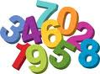
Mathematical development
- Counting games and rhymes.
- Reading, writing, ordering and counting numbers 1 to 20.
- Recognising different 2-D shapes in our school environment.
- Using 2-D shapes to complete a task.
- Create our own repeating pattern.
- Thinking about the number that is one more.

Understanding of the world
- Thinking about different celebrations such as Bonfire Night, birthdays, Christmas, Diwali and Eid.
- Using simple IT equipment.
- Looking at our environment and thinking about the seasonal changes.

Expressive arts and design
- Create firework pictures using different painting techniques.
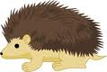
- Make clay hedgehogs and diva lights, using clay tools.
- Make colourful Rangoli patterns.
- Make food for Leo the lion’s birthday party.
- Different role play experiences.

Personal, social and emotional development
- Activities to encourage independence, concentration and confidence.
- Continuing to think about our classroom values.
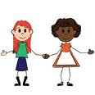
- Thinking about our own community.
- Forming relationships within our classroom.

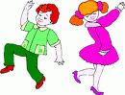
Physical development
- Developing an awareness of space.
- Using large play equipment safely.
- Travelling, using different parts of the body.
- Responding to music with a dance.

Your support
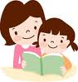
We hope you can assist your child in their learning by:
- Reading with them regularly.
- Helping them to learn their key words and sounds weekly.
- Reminding them to bring their reading book to school every day.
- Useful websites: www.topmarks.co.uk, (early years section) www.bbc.co.uk/cbeebies , www.phonicsplay.co.uk (phase 1,2 and 3 games)
Hopefully you are all able to access our online assessment platform, Tapestry. We welcome any comments and photographs of your child’s learning at home. If you need any help doing this, please just ask.
.

Important dates:

Tuesday 18th December- Hot Christmas dinner

Thursday 20th December- Cold Christmas dinner

Monday 7th January-INSET day

Wednesday 8th January- Pupils return to school

Thank you for your support.
Mrs Wolfe

